Activity: Make your own rock carving (petroglyph) – see step by step photos below
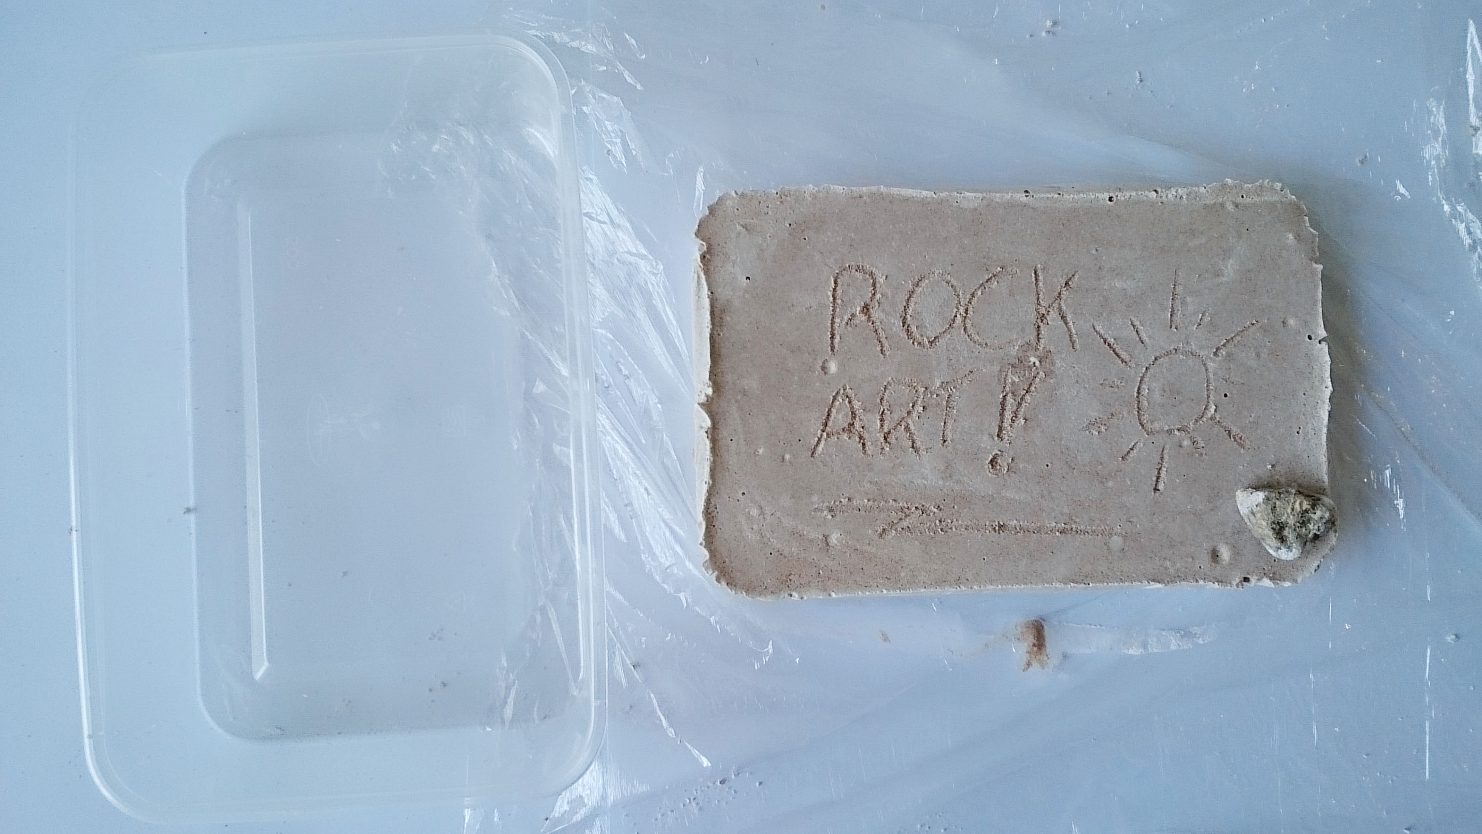
You will need:
Dental plaster (Or other child-friendly plaster like plaster of Paris, dental is hypoallergenic and sets in 10-15 minutes, plaster of Paris takes about an hour. We use Maragon Arts and Crafts – order 3x 1kg bags and you get a 4th free, this will be more than enough for a whole class and cost c.£8 – based on 100g plaster per child, see below )
Sand (children’s play sand is best and safest, c.£.350 for a 15kg bag from Argos, Wilkinsons, Homebase etc. will be more than enough for a whole class)
Water
Small flat plastic tubs (flat based take-away style tubs are ideal, if planning the session in advance you could ask pupils to bring these in from home for free)
Cling-film
Small stones/pebbles (preferably with pointy but not sharp edges, these could be bought or the children could ‘gather’ their own under supervision from around the school grounds)
Small plastic cups (supermarket ‘basics/value’ type, like you get in a vending machine)
Mixing bowls (any small bowl will do, but if you get extra takeaway tubs these work well, especially the slightly deeper ones)
Sticks for mixing (you could buy lolly sticks or the children could ‘gather’ their own stick under supervision from around the school grounds)
The PowerPoint: Prehistoric Rock Art – Make your own Rock Art

- Explain to pupils that monuments like Stonehenge aren’t the only symbols left for us to use to try and understand what prehistoric people thought. Another really good source of evidence for archaeologists is ‘Rock Art’. In this session they will learn about Rock Art and have a go at making some of their own.
- First they need to make their own ‘rock’ – mix plaster with sand (use a 2:1 ratio of sand to plaster, amounts will vary depending on size of your tubs – but for the ‘take-away’ type mentioned above 1 plastic cup of sand to 1/2 cup of plaster works well or 200g sand to 100g plaster), add water (1/4 cup) and mix. Pour into the small plastic tubs lined with cling-film, to about 1-1.5 cm thick; gently tap the tub on the table to knock out any air bubbles. (If you’re feeling impish you might want to swap these first two points around – have them come in and make their ‘rock’ but not tell them what it is or why they’re making it – it can make for some good discussions amongst pupils trying to guess what they might be doing!)
- Whilst their ‘rocks’ set (about 20-30 minutes) use the information provided (in the ppt) to look at Rock Art around the world and in Britain.
- Now focus their attention on the British Rock Art and how it is almost entirely made by carving shapes into rocks. They should now have learnt that the archaeological word for this is a petroglyph. Give each pupil a blank piece of paper and ask them to design their own petroglyph – they can make it ‘representative’ or ‘abstract’ (see ppt), but they mustn’t tell anyone else what it means….
- When they have done their design and their ‘rock’ is set they can use one of the small stones to carve their petroglyph into the rock. They must take care – you can’t rub out mistakes in rock! Nor can you fix it if you push too hard and break it – our ancestors used great skill in creating their Rock Art.
- After all the pupils have created their petroglyphs put them all in one place so that everyone can see each other’s. They are now archaeologists – they must look at all the designs and try to work out what their meaning is. Give them 5-10 minutes to look at them all – remind them they must remain totally silent, no asking questions or discussing just yet.
- To start the discussion pick up one of the petroglyphs, ask who made it, and then ask them to come to the front, but stay totally silent. Now start a discussion amongst the whole class – what do they think it’s a carving of? What might it tell us? What might it tell us about the person who made it? Let them use their imaginations – based on the evidence in front of them, like all good archaeologists do. After you feel the discussion has reached a conclusion ask the pupil who made it to explain their thoughts and reasons behind their design.
- This will allow you to introduce the concept of ‘interpretation’ and how one object can have many different interpretations. Raise the question of what would they have done if they hadn’t been able to ask their fellow pupil what the real interpretation was?
- Ask each pupil to pick up their petroglyph then split the class into groups so that they can repeat the same interpretation activity within each group. This way everyone gets to experience someone else trying to interpret their petroglyph.
- Finish by asking pupils what they have learnt about ancient cultures and how we as ‘modern’ archaeologists interpret them. Encourage higher level empathy and understanding of these historical concepts. What do they think an archaeologist in the future would make of their class as a society/culture based on their collection of petroglyphs? (Why not put all the petroglyphs on display for other pupils/teachers/parents and see what they make of your class based on the evidence before them! ;0)
- You could also do the same activity but instead of using a stone to carve a ‘petroglyph’, pupils could just use paints on their ‘rock’ to create a ‘pictograph’. Or get real value from your ‘rock’ and carve one side and paint the other! All of their ‘rocks’ could then be displayed as a ‘petroform’!

Step by step photos

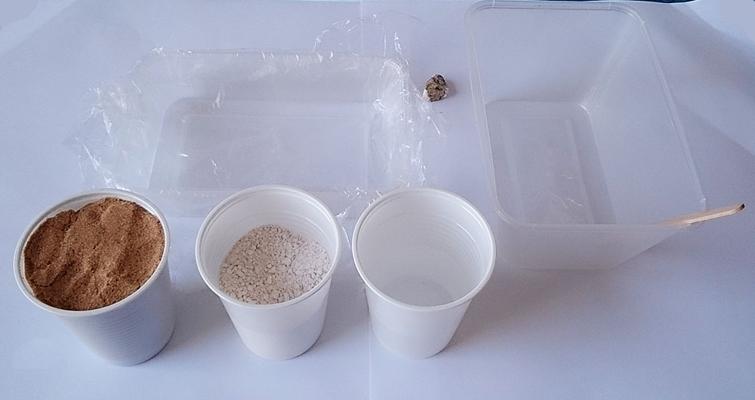
Step 1: Assemble everything you’ll need. (To save waste I don’t give each child a plastic cup, I assign a sand monitor, plaster monitor and water monitor – either adult helpers or responsible pupils, preferably an adult for the plaster. They stay in one place and the other pupils come around with their mixing bowls to receive their measure of sand and plaster (think Oliver Twist!)

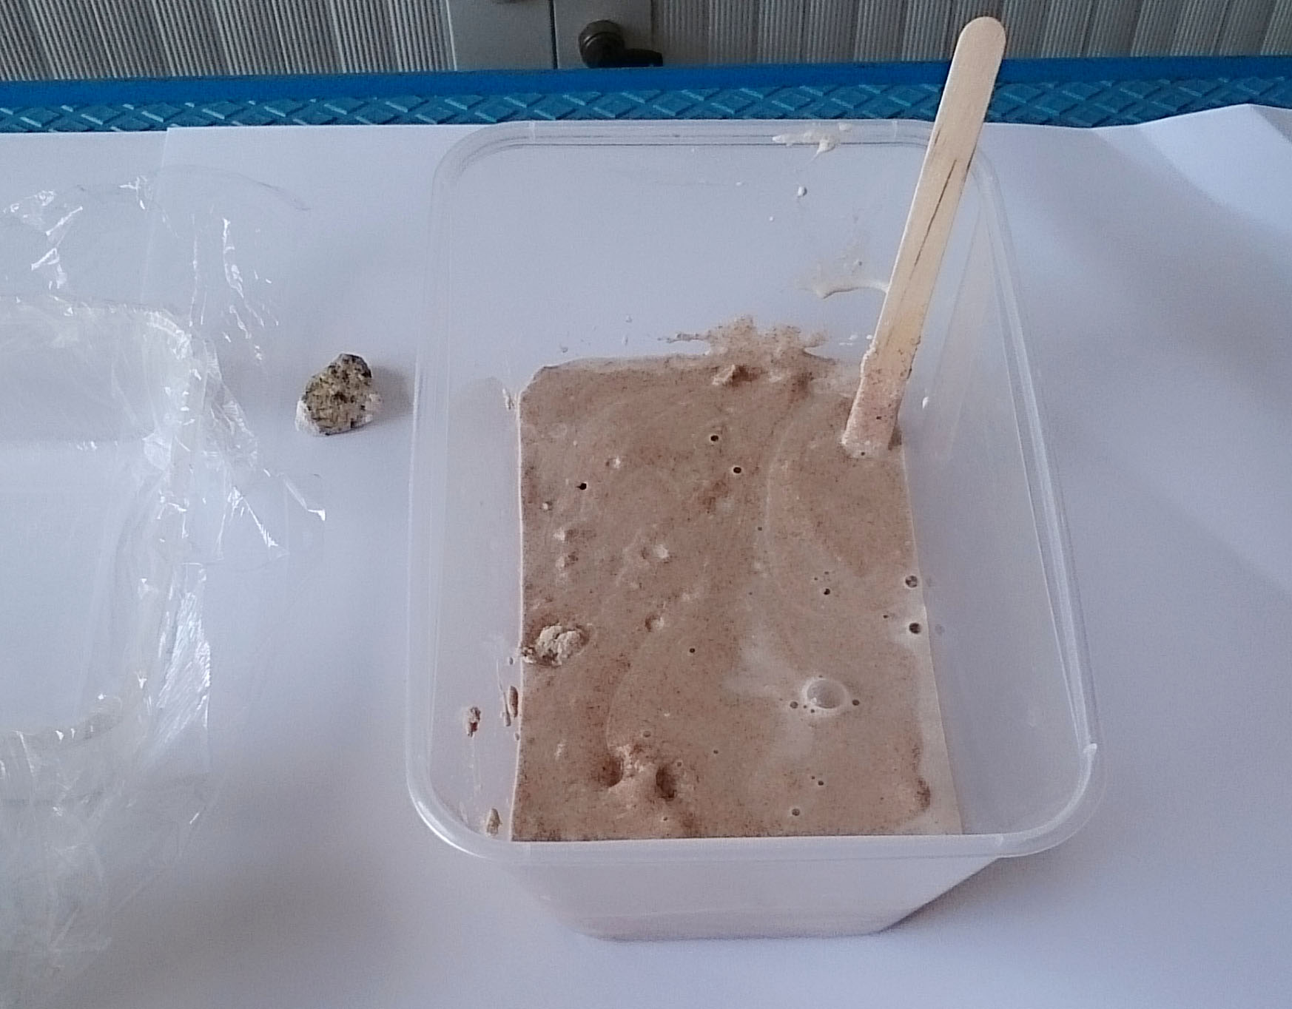
Step 2: Mix the sand and plaster together whilst still dry then add the water and mix – ‘sloppy porridge’ is a good description of the consistency you’re after.

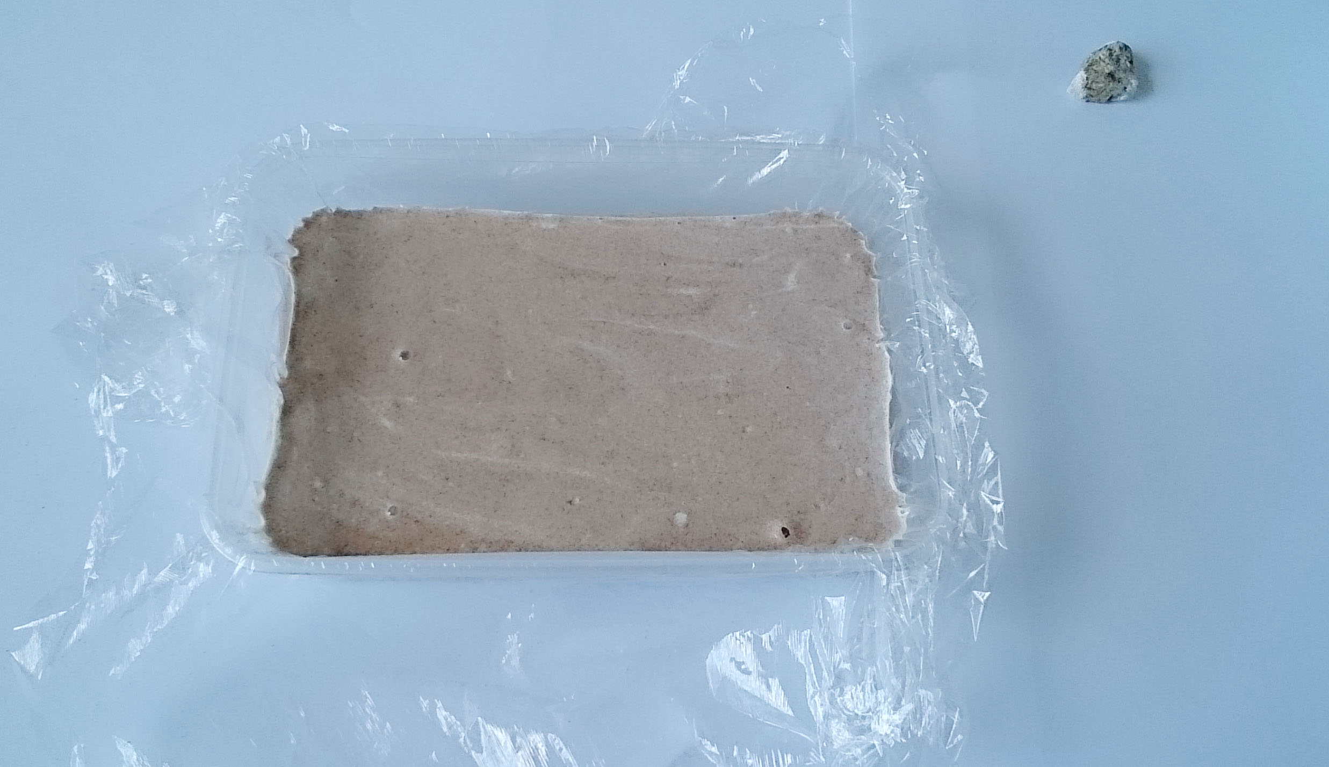
Step 3: Tip the mix into the shallow tub lined with cling film and leave to set for c.20 minutes.

Step 4: Gently push the plastic tub from the bottom and your ‘rock’ should pop out – then use your stone to carve it, making a ‘petroglyph’. (Make even more use of it by turning it over to paint a ‘pictograph’ on the other side and then arrange everyone’s to make a ‘petroform’!)

These instructions are intended to be used with the Teaching Activity: Prehistoric Rock Art: Make you own Rock Art.

NB: It’s the responsibility of the teacher to produce a Risk Assessment for this activity should your school require one

